**Instructions for Running FEB and BEB Automated Test Software on ASUS Amplab Computer**

[sweinreb@caltech.edu](mailto:sweinreb@caltech.edu) 626-665-9307 [haskar@uci.edu](mailto:haskar@uci.edu) 415-240-0670, June 28, 2020

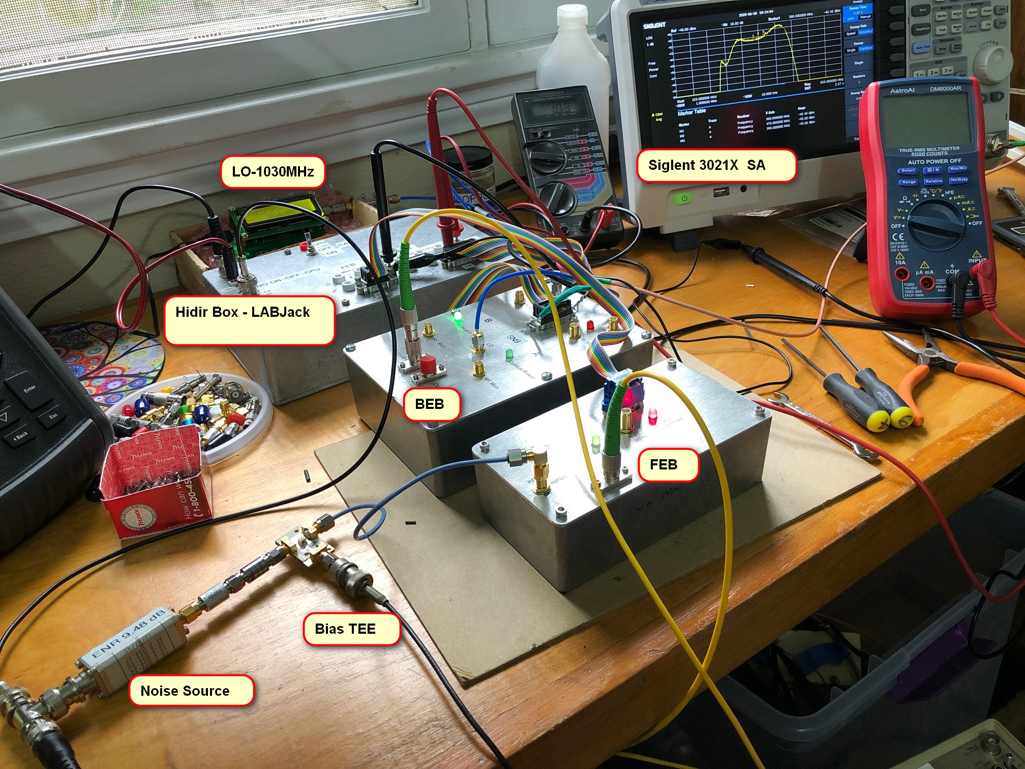

**Test Configuration – See Above**

Connect the ASUS computer with two USB cables the Hidir Box and the Siglent SA

Note the two 3-position toggle switches on the Hidir Box. They both should be in the CPU position

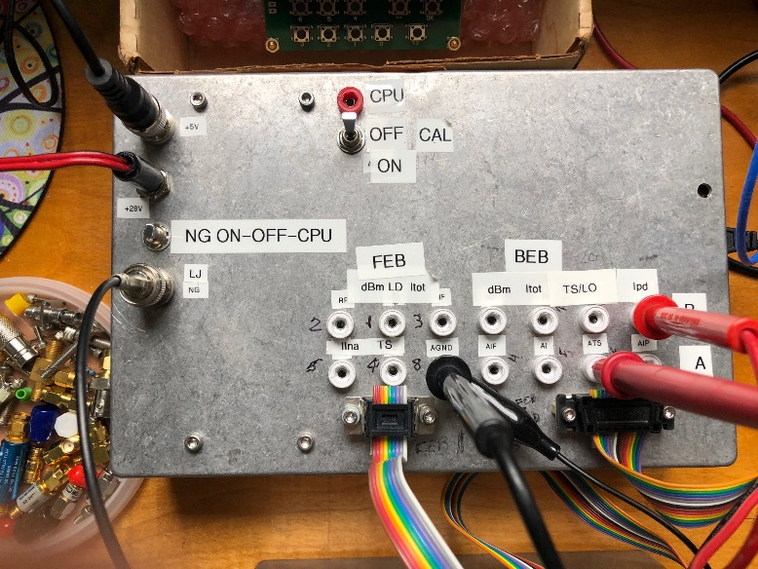

Connect the Hidir Box to +5.6V (<900 mA) and +28V (<10mA) power supplies

Set the LO to 1030 MHz using the push buttons on the box per instructions on the box cover.

Press the Present button on the SA to remove all previous settings; the test software will set all relevant setting correctly and the “Remote” note will appear on the SA center lower screen. To return to local control press Esc in the SA Edit area.

For the FEB or BEB to be tested the connections need to be made: power, input and output and for the BEB, Local Oscillator. Note that the BEB has A and B channels for fiber and output to the SA. While making fiber connection note the brightness of the green LED on the BEB. Jiggle and tighten the connector ferrule for maximum brightness. The BEB photo diode current can be read with a DVM to give a more certain measure; it should be between 0.8 and 1.2 V indicating approximately 0.8 to 1.2 mW for the adjusted 2mW FEB optical power in the FEB and with 3dB optical attenuator in the fiber cable.

**ASUS Amplab Computer Settings from a Cold Start**

Power button is in top right corner of keyboard. PIN is 150600

After startup, click the Spyder symbol in the task bar. Wait a few minutes for the C://Spyder Python 3.7 screen to load. The test programs with backups are in PC>Desktop>Test Software and the data file results are in PC>Desktop>FEB_BEBtestSoftware. The Spyder screen should look like:

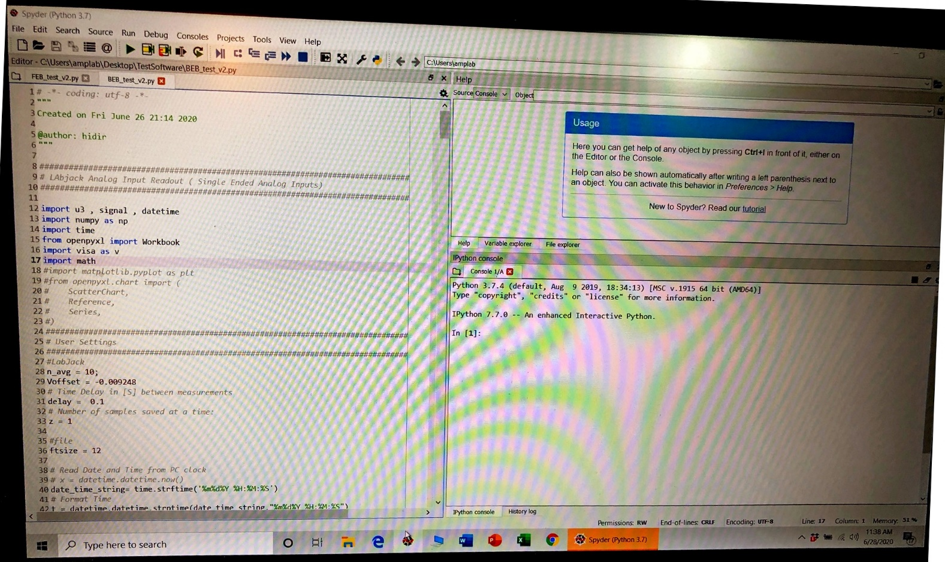

This screen has the Editor window at left and Console window at lower right. The choice of FEB or BEB test is made by selecting the program title in the 5th line from the top in the Editor window. To make this selection point the mouse at the text of the title (not the symbol which will close the program) it will brighten when selected.

The FEB or BEB program is then run by clicking on the triangle under the Run command on the 2nd line from top of the Editor window. **It is important to then move the mouse cursor over to the Console window before typing in the operator’s initials!** If the initials are typed without moving the mouse they appear in the Editor window and erroneously modify the program. If you do this, you can backspace to remove them. As a last resort, if you mess up the program you can load a backup program from the test software folder.

**Running the Software**

After clicking the Run triangle the SA is commended to the settings needed for the measurement and the FEB screen should look like the following:

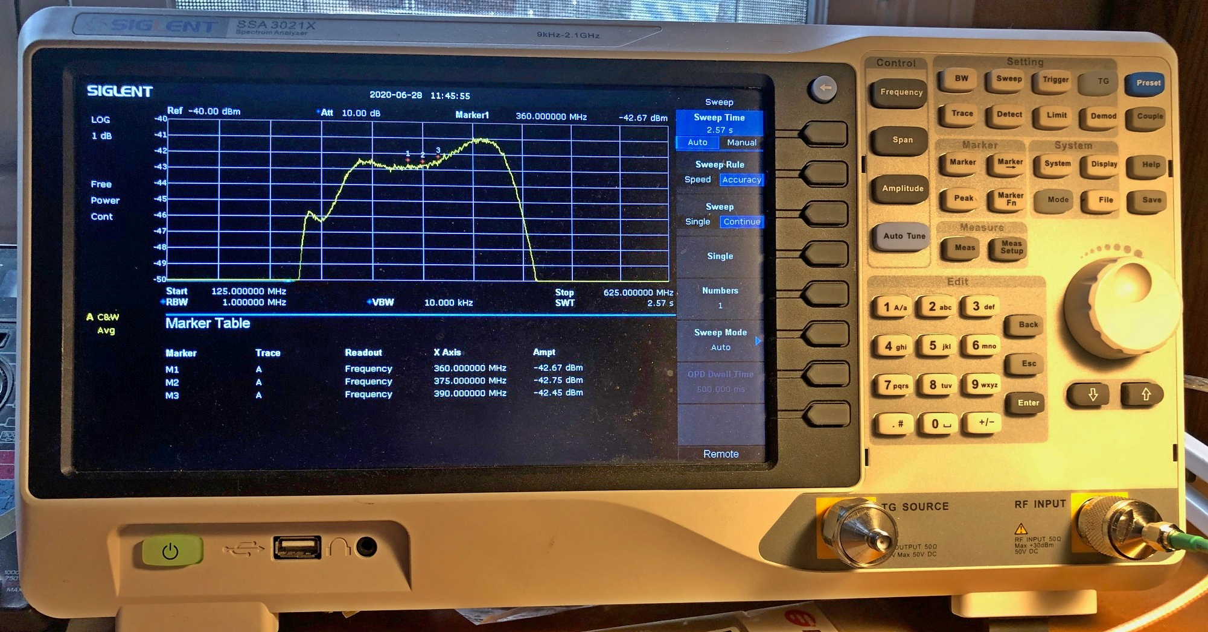

Type in the desired output file name and serial numbers for FEB and BEB. For the BEB the serial number consists of a number followed by A or B; **it is important to type in an upper case A or B**. The data collection then starts and the spectrum can be observed to go up as the noise source is turned on. After about 10 to 20 seconds the NF or the FEB/BEB cascade is printed in the Console window and should be between 9 and 11 dB. If it high, it is usually because the noise source did not got on and off due to an incorrect switch setting, missing cable, or faulty module. In this case if the measured noise temperature is negative the program terminates because of a math error - the NF calculation requires a log of a negative number.

After a measurement the program asks whether to measure another module (Y) or write the file (N) with as many modules as have been measured since the program start. After writing the file the program terminates and can be run again by clicking the Run triangle and again being careful to move the cursor before typing in initials. The program can also be terminated with no data file by a right click.

**Processing the Output File**

The test output file, either for FEB or BEB, is then found in C: PC>Desktop>FEB_BEB_test as follows:

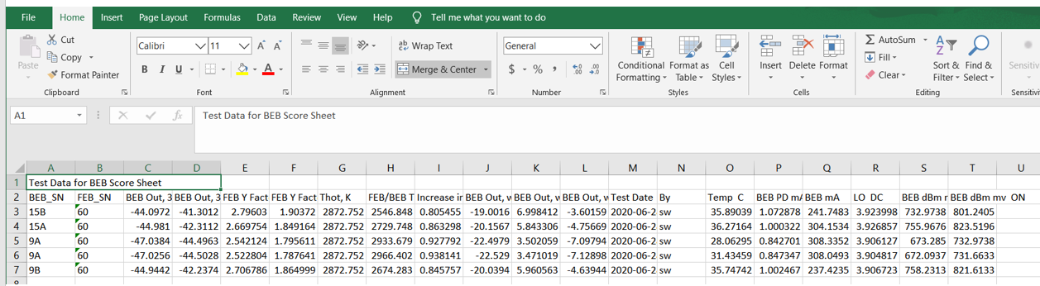

The rows with useful data, 3 to 7, in the above sample can then be copied and pasted (use Formula paste to pick up destination formatting in empty rows such as 67-70m the module score sheet in Dropbox, as in the following example. The copying is by selecting the rows and column and the pasting selecting only the top left hand cell. 